Biology Project (Ms. Sonali)
Topic - Explain any five modifications of leaves with diagrams.
Chemistry Project (Ms. Sonali)
Topic – States of matter and their general characteristics.
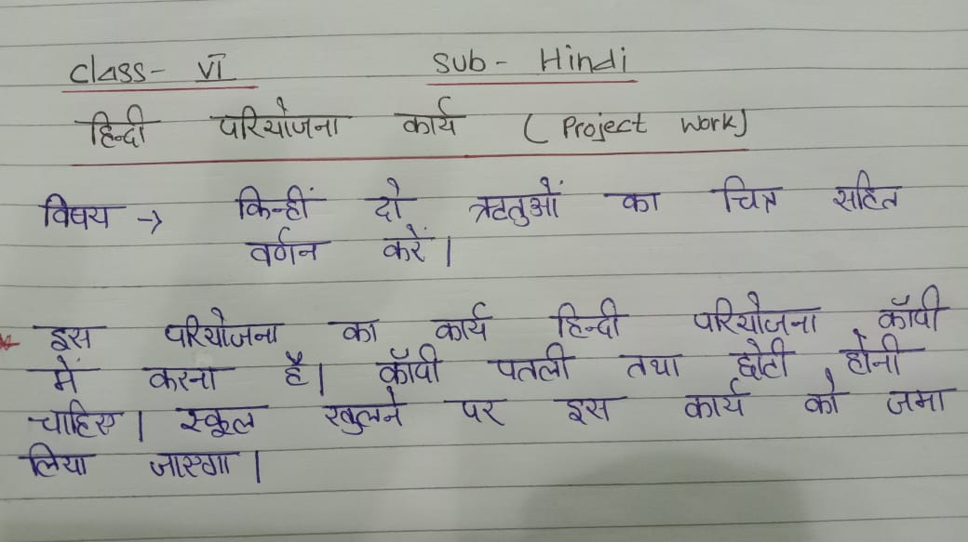
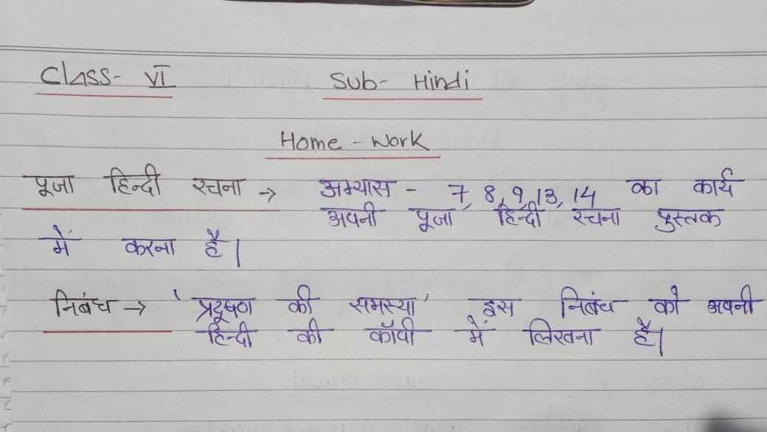

Std 6- MATHS Protect (By Mr. Abhijit Paul)
TOPIC- NUMBER SYSTEM
(eg- whole no, natural no, odd no, even no, prime no, composite no,... Etc)
Their definition with eg..
Draw a number tree also..
Can take help from book and internet..

DE NOBILI SCHOOL MAITHON
COMPUTER PROJECT
CLASS -6
(Project work must be done in small size practical copy)

1)Prepare a table that comprises the marks of the first ten rank holders of your class. The sample is shown as:

Rank | Name | Total
1 | Pragya | 889/900
2 | Aditya Singh | 876/900
3 | Aman Kumar | 855/900
4 | Anjali Kishore | 833/900

Now, perform the following tasks and write the steps:
- Align the names at the bottom center (vertical alignment) of the heading column.
- Align the ranks at the center of the heading.
- Add border of your choice to this table.
- Highlight the row who contribute the highest mark.
- Increase the column width of ‘Total’

2)Create a MS –Word window and label its different parts. Also explain the function of different parts

3)A folder ‘Master ‘is on C drive and contain the files Bio-data.docx, Result.docx, Nation.pptx and Notice.txt. Perform the following with defined files:
a. Copy the file Bio-data.docx to D-drive.
b. Move the file Result.docx to pen drive.
c. Search the file Notice.txt on the hard disk
d. Delete the file Nation.pptx.
(Note: You have to write the steps for the above operations)

PROJECT WORK ( STANDARD 6 )
WORK ASSIGNED TO BE DONE AT HOME.
ENGLISH LANGUAGE
TOPIC : WRITE A COMPOSITION ON :
THE PERSON I ADMIRE THE MOST.
( DRAW AND PASTE PICTURE OF THAT PERSON )

HISTORY & CIVICS
TOPIC : DIFFERENTIATE BETWEEN THE MESOPOTAMIAN CIVILIZATION AND THE EGYPTIAN CIVILIZATION .( BASED ON OCCUPATION, RELIGION AND MAJOR ACHIEVEMENTS).MENTION TWO POINTS EACH.

TOPIC FOR PROJECT REPORT CLASS VI (PHYSICS)
DIFFERENT TYPES OF FRICTION

